

Students’ Placement Office, IIT Kanpur
Title of the Project | TSMC Revenue Prediction using Time Series Analysis
Commencement Date | May 6, 2023
Completion Date | July 4, 2023
Project Supervisor | Dr. Subhas C. Misra
Organization/Institution where the Project was accomplished | Indian Institute of Technology Kanpur
Project Description (You can use extra A4 sheets in case you run out of space however the extra sheets should also have the seal & signature of the Project Supervisor or the relevant authority )
This project presents an analysis of the monthly revenue of Taiwanese Semiconductor Manufacturing Company (TSMC) using time series models. Specifically, three different models, namely SARIMA, Holt-Winters, and FB Prophet, were compared to determine their forecasting performance. Evaluation metrics such as Mean Absolute Error (MAE), Root Mean Square Error (RMSE), Mean Absolute Percentage Error (MAPE), and Mean Absolute Scaled Error (MASE) were employed for model comparison. The objective was to select the best-performing model based on these metrics and provide an accurate revenue forecast for the next quarter. The analysis began with a comprehensive exploration of TSMC’s monthly revenue data, examining trends, seasonality, and other patterns that could impact revenue. Subsequently, the SARIMA, Holt-Winters, and FB Prophet models were trained using historical revenue data. The performance of each model was evaluated using the aforementioned metrics, enabling the assessment of accuracy and robustness in capturing revenue patterns. By comparing the results, the model that yielded the most accurate forecasts for TSMC’s revenue was the SARIMA model. The selected model was then used to forecast revenue for the upcoming year, providing valuable insights for stakeholders such as investors, analysts, and decision-makers. The research paper also highlights the strengths and limitations of each model, contributing to the field of time series analysis and offering a foundation for further research in revenue forecasting and related domains.
Project Verification Form
By appending your signatures to this form you acknowledge and agree that:
- This form along with the certificate would serve as the official document between the project supervisor and Students Placement Office, IIT Kanpur regarding verification of the student’s project work
- The student will provide additional information and documentation relevant to his/her project upon request by the Students’ Placement Office
- The student has clearly defined his/her individual role in projects done in cooperation with other students, faculty, groups or company personnel.
- Incorrectly over-stating the reach, impact and/or quantitative/qualitative results of a project is unethical.
- In case of violation of any of the above rules, Students’ Placement Office, IIT Kanpur reserves the right to take necessary action including de-registering the student from the placement season and reporting the misconduct to the Institute Authorities.
Submitted by:- Rohit Jangid | Project Supervisor Details:-
Name: Rohit Jangid | Name: Dr. Subhas C. Misra
Roll No: 210872 | Designation: Professor,  Department of Industrial and Management Engineering
Signature:  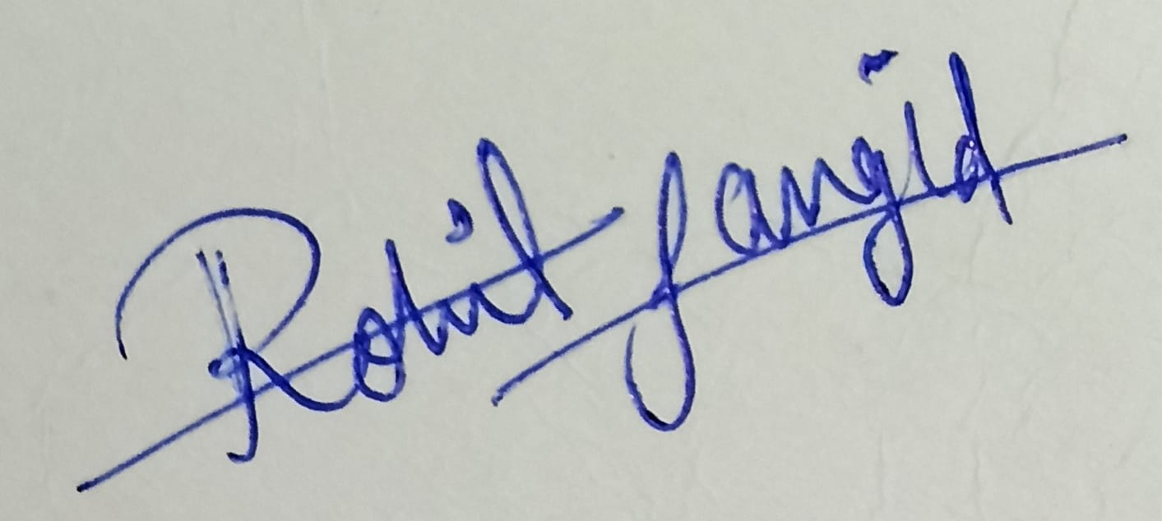 | Signature:

